Joan Jordan EDUC 674 - Professor Klein
8/16/09 Final - Term Paper

Assistive and Learning Technologies for Students with Disabilities and Special Needs AMDi

Advanced Multimedia Devices, Inc (AMDi) is a US based company with a product line of high quality and easy to use communication devices for special needs customers. ADMi began as a medical device company in the 1980s. Lack of profitability caused the company to change the business focus and merge with NISCO Systems, a Georgia base designer/supplier of high speed telecommunication devices. AMDi is located in Farmingdale, NY with manufacturing facilities in Hong Kong.
AMDI has a broad product line ranging from low tech single message devices to the EyeGaze Electronic Hand Held E-Tran system. During my observations of AAC devices at the Jesse Kaplan School, I was introduced to AMDi products. The Kaplan school serves students with cognitive and multiple disabilities ages 5-21. Each classroom had at least one Partner plus Four Standard device manufactured by AMDi. This is one of the company’s most popular products. The 4 Square, as it is called by speech therapists, is a low tech self-contained message communication device with four communication selections at two levels. Picture cards called graphic overlays are easily slid between the housing and message square. The device is pictured below.
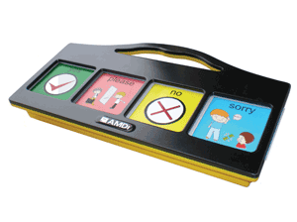
A user can record and playback 4 messages at two levels. The messages can be up to 6 seconds in length. It is simple to operate. After the unit is turned on, pictures inserted, voice recorded and the volume adjusted students can select a picture by pressing it. This activates a corresponding message. At the Jesse Kaplan School, when four selections were beyond the ability of students to be able to evaluate, the speech therapist covered up two of the pictures. The rational behind doing this, instead of purchasing a Two Square device, is that the cost for a second device is unjustified because the Four Square can easily be used as a Two Square. A Four Square costs approximately $350 with a complete set of graphic overlays. The Four Square is a durable unit subjected to rough handling. It is designed to be drop resistant, water resistant, shatterproof, and light weight. This simple device is a necessity for the classroom serving students who are non verbal with severe cognitive delays.
Another popular AMDi device is the Smart/128 Multilevel Communication Device. This is a self-contained 6 level communication device, which allows the user to record and playback 768 distinct messages of up to 4 seconds each.

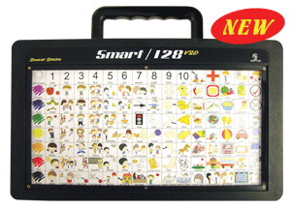

The Smart/128 is simple to operate once the message are recorded, the desired overlay is slid into place and the volume is adjusted. The user pushes the message square to play the corresponding message. As with all AMDi products, the Smart/128 is designed for durability under rough handling conditions. The cost for a Smart/128 is $ 1,620 for a complete kit. The ability to quickly and easily communicate thought the use of this device has allowed thousands of students to more fully participate in learning and in life.
AMDi’s commitment to designing and manufacturing low cost, high quality and easy to use communication devices has enabled the company to steadily increase market share. A strong after sale support and service group ensures customer satisfaction. Before sale services include a loan and rental program which allows customers to evaluate the product extensively prior to purchase. Additional presale support is provided to assist with all insurance, Medicare and Medicaid claims. AMDi products improve the lives of people with severe speech disorders through providing reliable and easy to use devices.

