Dynavox Company

Giovanna Paredes

EDU 674

Professor Klein

The Dynavox Company

Giovanna Paredes

EDU 674

Professor Michael Klein

08/18/09

**History**

Twenty-six years ago a company named Sentient Systems Technologies was founded to provide the gift of communication to individuals who were unable to speak due to conditions such as cerebral palsy, autism and traumatic brain surgery. Later, this company developed into what it is now Dynavox Technologies. The journey to becoming the world’s leading provider of Augmentative and Alternative Communication (AAC) solutions beganwhen a businessman and an undergraduate student in partnership with Mark Friedman formed Sentient Systems Technologies Inc. The company’s first commercial product was the Eye Typer. This was a tool that allowed individuals to “speak” by composing and speaking messages using eye-gaze techniques; the patent for this product was sold to the U.S. navy. In 1991, the original Dynavox branded products began shipping to consumers. Devices, featuring touch screens with a dynamic display of words and symbols that changed with the selections of the person using the device. By the end of 1993, Sentient Systems introduced word and grammar prediction allowing individuals to compose messages more quickly. After a merger with Sunrise Medical Inc. in 1998, Sentient Systems changed its name to Dynavox Systems Inc. The company become Dynovox Systems LLC in 1999. In January 2001, medicare coverage for AAC devices become available for consumers. In 2002 the company released the DynaWrite, the first keyboard-based communication device. DynaWrite was the first Dynavox product to feature Verivox voices. In May 2004, Mayer-Johnson became part of Dynavox adding picture communication symbols to the devices. On July 2009, Dynavox Systems LLC announced that the company had merged with Blink Twice. Blink Twice develops and manufactures the Tango, a novel and innovate communication solution designed primarily for children and teens with significant speech and language challenges. This mergence will extend Dynavox reach into the education and child-focused speech device market. It will also reinforce Dynavox commitment to provide appropriate communication solution for each consumer’s unique needs.

**The Tango Device**

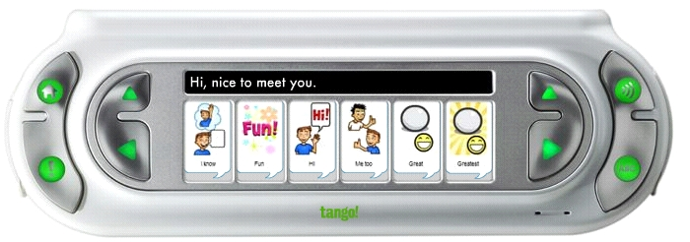

The Tango is the most innovative AAC device available. It's the only device that provides multiple modes of communication, so individuals can best meet many communication needs in diverse situations. It is designed for children who rely on AAC and for teachers who are committed to educating special-needs children. The Tango was created to address real-world problems. It was created especially for children, teens and secondary school students with special needs.

This is an amazing tool for social and linguistic competence is characterized by the following features:

* Phrase first allows entire phrases to be spoken, for quick and natural communication.
* Core First Mode builds literacy with quick and easy access to 90 key words for word-by-word message generation.
* Word Morphs let consumers create plurals, conjugate verbs, and do adjective comparisons with the press of a button.

In addition, it has a built-in camera, 6 communication modes, computer connectivity, full peripheral support, voice Morphing, almost 2,000 recorded phrases and over 4,000 words. The price for this device is $6899.00. It includes one character set, a clear stand 50°, a jelly wedge, a SD card reader with a USB extender, a back-up SD card, an AC adaptor, the Tango Link Software (with Cables), Tango Lab software, a manual, word locator, one-year warranty and 30-day money-back guarantee. For the transition from children to teens it can simply be done by swapping an SD card. In addition, the Tango meets Medicare and Medicaid guidelines.

**The DynaVox Xpress Handheld Communication Device**

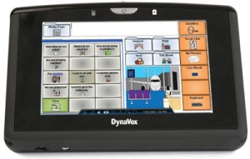

Dynavox is launching a handheld communication device for those that suffer from a speech impairment caused by a stroke/aphasia, autism, Down syndrome, traumatic brain injury or ALS. Compact and lightweight, the Xpress can easily fit into either a pocket or a ladies purse. In addition to a dictionary of words, phrases and emoticons, this handheld device supports both Wi-Fi for web access as well as Bluetooth so that PC accessories such as mice and keyboards can be attached. The Xpress comes with 8GB of flash memory that can be used to store multimedia files such as digital photos, MP3 and video files. It is anticipated that this device will retail at the end of August for $7,500. Some funding for the purchase of this product may be available through Medicare, Medicaid and some private health insurance providers. A lot has changed at Dynavox Technologies since the company was founded in 1983. But one thing that hasn't is their commitment to bring the gift of communication to augmented communicators across the world.

|  |  |
| --- | --- |
|  |  |
|  |  |