Herendyra Pereyra
EDUC 674
Prof. Klein

Dynavox and Its Products
Dynavox is the most innovative developer of augmentative and alternative communication products and services. Augmentative and alternative communication products are used by individuals with disabilities such as speech, autism and those that are suffering from ALS, cerebral palsy, stroke, brain injury among others. Dynavox has been opening many doors for individuals with speech impairments and learning disabilities thus they can too be able to communicate.
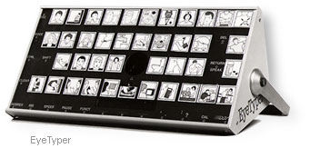
Dynavox was founded in 1983. It was founded under the name of Sentient System Technologies. This company began emerging into the world of augmentative and alternative communication when Tilden Bennett and Gary Kiliany partnered with mark Friedman. At that time they created their first product, The EyeTyper. This tool allowed individuals to compose and speak messages by using eye-gaze techniques.
The company's mission is to help individuals and their families regain the ability to communicate. They work with their clients to meet their needs. Learning should not be detained by any disability or impairment that is why Dynavox offers a solution to anyone who is not able to communicate naturally.
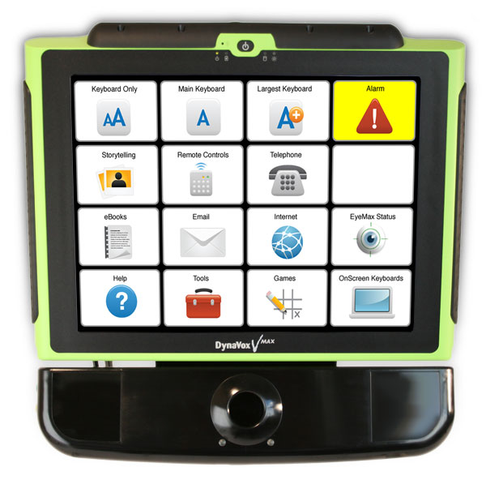
Dynavox has many different products. Among these products are the following V & Vmax, Eyemax System, X press, Tango, M3, DynaWrite, Co-pilot, Communication software, and Education software.
The lasted product that they have released is the Dynavox Eyemax System. This system makes it possible for individuals with cerebral palsy to use their eyes to access the device, and be able to communicate. This product is the most advance technology of its nature. Anyone can use the Eyemax system. In order for the user to have full control of the system he/she needs to be able to look up, down, left and right. The Eyemax has AT&T natural and Acapela HQ Voices, they sound natural. It includes powerful speakers and unparalleled voice projection.
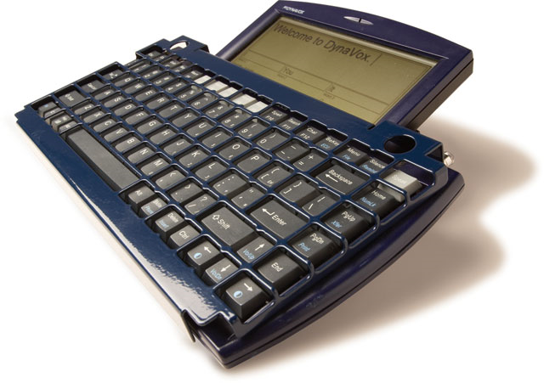
The Dynavox DynaWrite provides its users with the ability to control their environment by giving them independence. This product is perfect for individuals with literacy skills. Individuals are able to type using the keyboard-based system. It is amazing how this product has a synthesized voice which produces the phrase or word that the individual types. The DynaWrite can be connected to a computer. It is ideal to talk on the phone and it work as a remote control for general household domestic devices; such as TV, CD or DVD player. This device is usually called as the “Type-and-Talk” Dynavox device.
Dynavox has a mission to help individuals who are unable to connect through speech with the world. They have designed products that facilitate a natural communication between these individuals and their families. Products such as, The Eyemax are changing the way people who suffer from Cerebral Palsy can have a dialog. The DynaWrite allows individuals with speech problems to communicate freely. This company is absolutely changing people’s lives.

